Redux-Saga vs Redux-Thunk

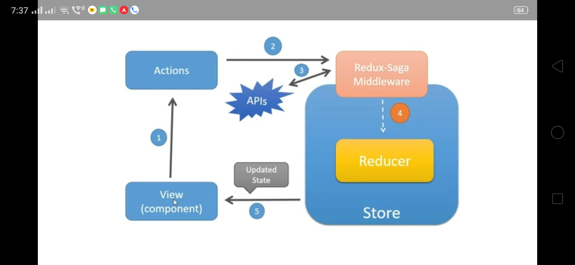

Redux-thunk:

* In redux-thunk we pass thunks called Functions to perform async operation (like axios call) then dispatch actions to reducer to update the store state.
* Component do not have direct communication with thunks in redux-thunk.
* Also there may be a problem of function callback hell
* Redux-thunk returns promise so difficult to do testing.
* But thunk is clean and used for small projects and you do not need to learn generators and keywords of functions called saga-effects.

REDUX-SAGA

* In saga, we can avoid callback hell and we can avoid passing function and invoking inside.
* You can easily test asynchronous data flow with saga.
* Call and put methods in saga returns javascript object so we can test each value yielded by saga effects (thunk returns promise so difficult to test)
* For Redux-thunk , we need mocked functions (API) for fetch data (REST API) which is not required for saga. This makes test easy, clean and readable.
* Both are good but depends on the context.